TASK SHEET 1: DOUBLE FIGURE EIGHT WITH A BITE KNOT

Name: _________________________________________________ Period: _______________

Directions: Read the steps listed below and use the illustrations at the bottom of the page to practice tying the bite knot. Keep practicing until you are told to stop.
- Double up the length of rope and form a loop with the closed end.
- Come around open ends with closed ends.
- Bring closed end back through loop.

TASK SHEET: DOUBLE FIGURE EIGHT AND FOLLOW THROUGH KNOT
Name: ____________________________________________________ Period: _______________

Directions: Read the steps below and use the illustration at the bottom of the page to guide you in tying the knots. Keep practicing the knot tying until you are told to stop.

- Make a loop near one end of the rope.

- Bring end of rope behind loop.

- Bring end of rope around loop and back through between sections of rope.

- Tighten knot. Figure eight should appear.

- Extend rope until enough is beyond figure eight to reverse process. Reverse rope between sections.

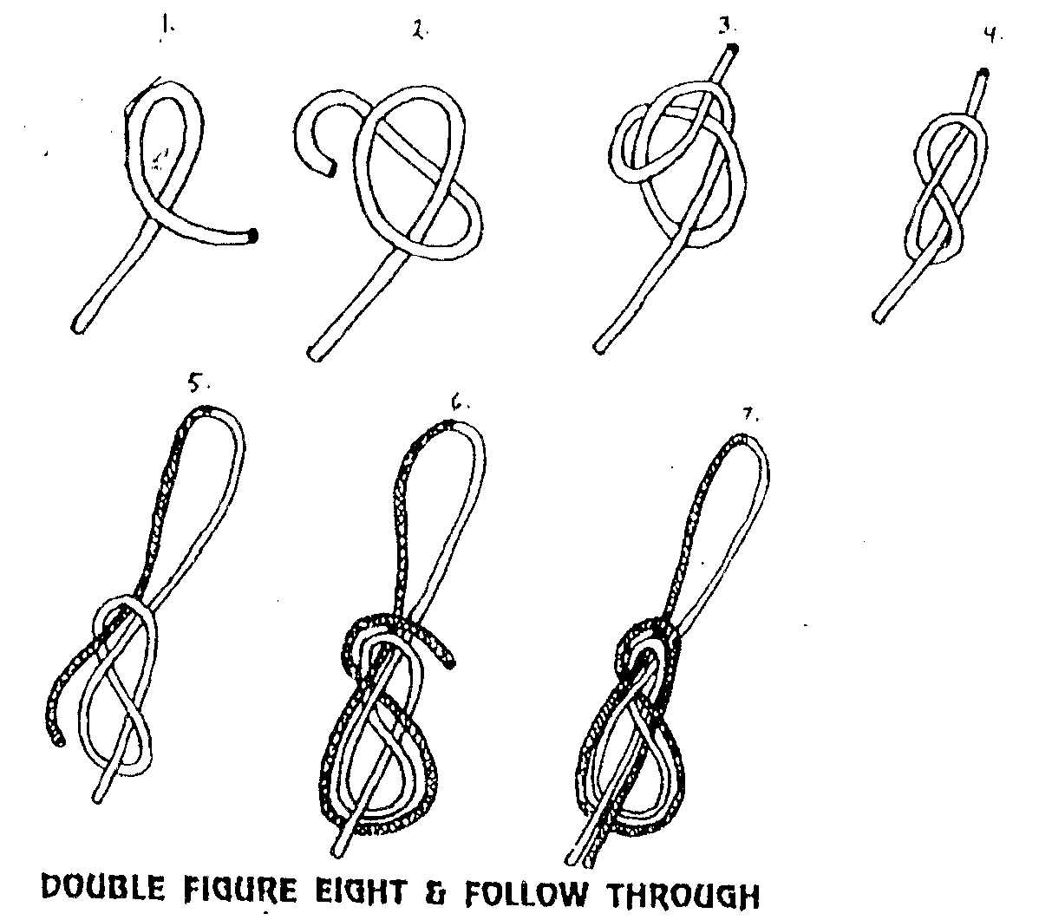
- Continue to retrace path of original knot.

- Complete retracing path and tighten knot.

