TASK SHEET 19: MUSCLE GROUPS OF THE BODY

Name: ______________________________________________________________________

Objective:
Upon completion of this lesson, you will:
1. Identify the major muscle groups of the body on a chart.

Instructions:
In this lesson you will study the major muscle groups of the body. It is important for you to know the location of the muscles in your body in order to improve your understanding of how they work and how to exercise them. Study the diagram that follows until you feel that you are ready to be tested on the muscle locations. When you are ready, see your instructor for the exam. You must pass the exam with a score of 80% before you go on to the next lesson. If you do not score 80% on the exam, study the diagram again and retake the test.

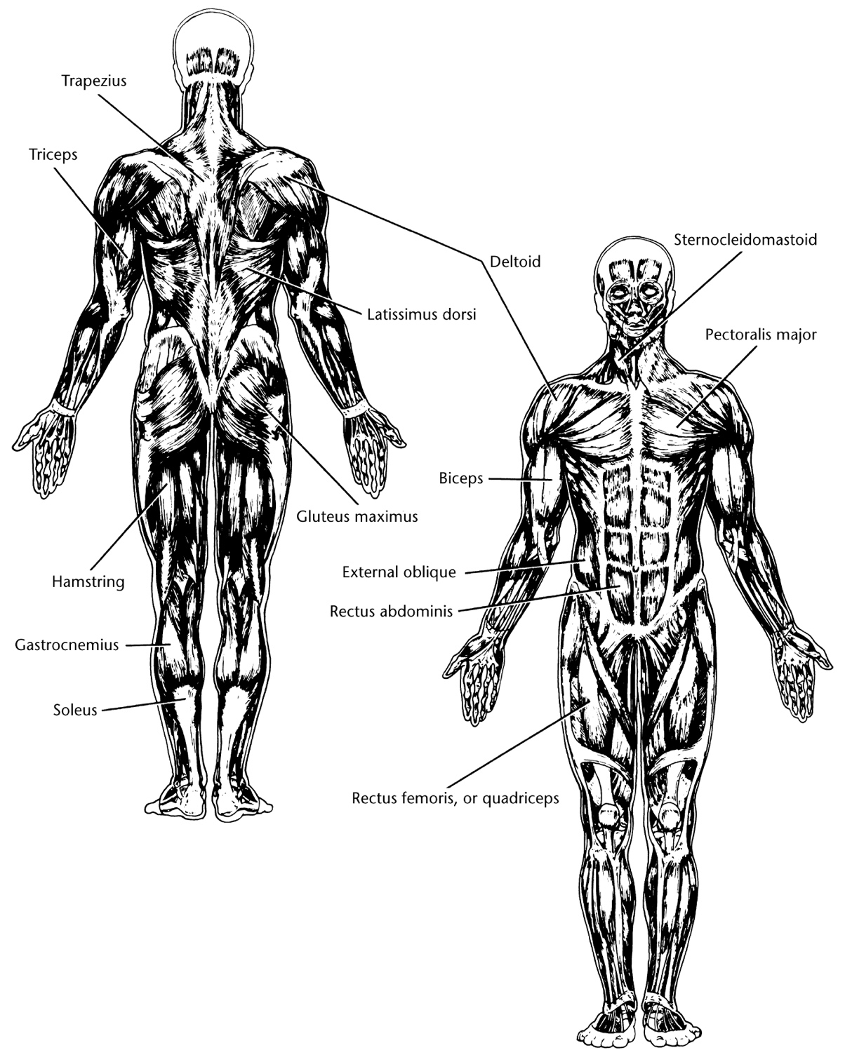

TASK SHEET 20:
THE OVERLOAD PRINCIPLE AND THE PRINCIPLE OF SPECIFICITY

Name: _______________________________________________________________________

Objectives:
Upon completion of this lesson, you will:
1. Identify the overload principle on a written exam.
2. Identify the principle of specificity on a written exam.

Instructions:
This lesson is presented with a paragraph of information followed by questions pertaining to the paragraph. The answers to the questions are found below the three asterisks (***) that follow each question. By folding a piece of paper and sliding it down the page, you keep the answers covered until you have made a response to the question. After respond, slide the paper down and compare our answer with the answer given below the asterisks. If your answer is correct, then go to the next question. If your answer is incorrect, then review the preceding paragraph and find out why your answer was wrong. Be sure to write the correct answer on your lesson.

Overload Principle
To improve in any area of physical fitness, you must constantly work your body at levels that it normally doesn’t encounter. For example, to improve flexibility you must stretch your muscles beyond the point that they are normally stretched in your everyday activities. To improve your muscular strength or endurance through weight training, you must lift an amount of weight beyond what is normal for you. To increase the size and strength of your biceps (upper arm), you would need to curl a barbell or dumbbell of adequate weight. You would not “overload” your muscles or benefit from simply flexing your arm a few times. Moving the weight of your arm is an activity that is encountered every day.
1. The overload principle states that you must work your body at levels that it (does/doesn’t) ___________ normally encounter in your everyday activities.
*** doesn’t
2. To improve flexibility, you must ________ your muscles beyond the point that they are in your everyday activities.
*** stretch
3. To improve your muscular __________ or endurance you must lift an amount of weight that is beyond what is normal for you.
*** strength
Principle of Specificity
The principle of specificity states that you must exercise a particular component of fitness to improve that particular component. For example, in order to improve cardiovascular fitness, you would run between fifteen and thirty minutes several times per week. To increase your flexibility, you would do a variety of stretching exercises. Therefore, if it is gains in muscular size, strength, endurance, or tone that you are seeking, you should engage in a quality weight training program.
1. The principle of specificity states that you must ___________ a particular component of fitness in order to improve that particular component.
*** exercise
2. In order to improve flexibility, you would perform ____________ exercises.
a. running c. stretching
b. lifting d. no
*** c
3. In order to improve muscular strength, size, endurance, or tone, you would engage in a _______________ program.
*** weight training

TASK SHEET 21: ABDOMINAL CRUNCH

Student’s Name: ________________________________________ Date: __________

Student Information: In this lesson you will learn the proper form for performing the abdominal crunch. Stronger abdominal muscles will help support your upper body and take the burden off your weaker lower back muscles. By strengthening your abdominal muscles, you can help reduce your chance of lower back injury.

Objective: While using proper form, you will perform two sets of abdominal crunches, performing the maximum number of repetitions in each of the sets.

Directions:
1. Go to the abdominal exercise area and practice performing the abdominal crunch.
2. Mark the appropriate response (YES/NO) for each checkpoint for the abdominal crunch.
3. Repeat this lesson until you have responded “yes” to all the checkpoints.
4. After successfully completing this lesson, go to your instructor for your skills test on the lesson.

 | Yes | No
ABDOMINAL CRUNCH

1. Assume a supine position (on your back) on the floor with your knees bent and our feet flat on the floor.
2. Cross your arms over your chest with your hands touching the opposite shoulders.
3. Tuck your chin to your chest.
4. Always keep your lower back in contact with the floor.
5. Inhale.
6. Curl up, lifting only the shoulder blades off the ground.
7. Exhale in the “up” position.
8. Return to the starting position.
9. Inhale in the “down” position.
10. Perform one set of as many repetitions as possible using proper form.
11. Perform a second set of as many repetitions as possible using proper form.

TASK SHEET 22: LEG PRESS

Student’s Name: ________________________________________ Date: __________

Student Information: In this lesson you will learn the proper form for performing the leg press. You will be working with a partner in this lesson. One person will be the lifter (doer), and one will be the observer/recorder. Change roles with your partner after completing the lesson. Avoid “locking” the knee joints when performing the leg press as this places excessive stress on the joints and may increase your chance of injury. The leg press exercises the quadriceps muscles.

Objective: You will perform one set of ten repetitions of leg presses while using your maximum amount of weight and proper form.

Directions:
1. Choose a partner that you would like to work with while completing this lesson.
2. Go to the appropriate viewing station with your partner and view the videotape on performing the leg press.
3. Go to the leg press machine with your partner and decide who will be the doer and the observer.
4. The doer will practice performing the leg press while the observer records and gives feedback. You will repeat this lesson until you have received “yes” responses at all the checkpoints.
5. The observer will check the appropriate response (YES/NO) for each checkpoint for the leg press. The observer should check only one checkpoint at a time and give verbal feedback to the lifter on each checkpoint marked “no.”

 | Yes | No
LEG PRESS

1. Select a weight that might be performed for a total of only ten repetitions.
2. Assume a position in the seat with your back resting against the backrest.
3. Place the balls of your feet against the pedals with the toes pointed straight up.
4. If possible, adjust the seat to a position where your legs are bent at or slightly less than right angles.
5. Grasp the handles if provided or fold your arms in front of your body.
6. Maintain body contact with the bottom and back of the seat throughout the lift.
7. Inhale.
8. Extend your legs completely and avoid “locking” the knees.
9. Exhale when your legs are extended approximately two-thirds of the distance.
10. Slowly control the weight back to the starting position.
11. Inhale approximately two-thirds of the distance back.
12. Perform one set of as many repetitions as possible using proper form.
13. Apply the principle of progression to find your maximum weight for ten repetitions.
14. Perform one set of ten repetitions using your maximum weight and proper form.

